Q1

import java.util.Scanner;  
class PortfolioAnalyzer{  
 double[] calculateDailyProfitLoss(){  
 Scanner get = new Scanner(System.*in*);  
 double openingBalance[]=new double[5];  
 double closingBalance[] = new double[5];  
 double profitLoss[] = new double[5];  
 int i;  
 System.*out*.println("Enter opening Balance");  
 for (i=0;i<5;i++){  
 openingBalance[i] = get.nextDouble();  
 }  
 System.*out*.println("Enter closing Balance");  
 for (i=0;i<5;i++){  
 closingBalance[i]= get.nextDouble();  
 }  
 for (i=0;i<5;i++){  
 profitLoss[i]=closingBalance[i]-openingBalance[i];  
 System.*out*.println(profitLoss[i]);  
 }  
 return profitLoss;  
 }  
}  
public class Main {  
 public static void main(String[] args) {  
 System.*out*.println("Hello world!");  
 PortfolioAnalyzer D1 = new PortfolioAnalyzer();  
 D1.calculateDailyProfitLoss();  
 }  
}

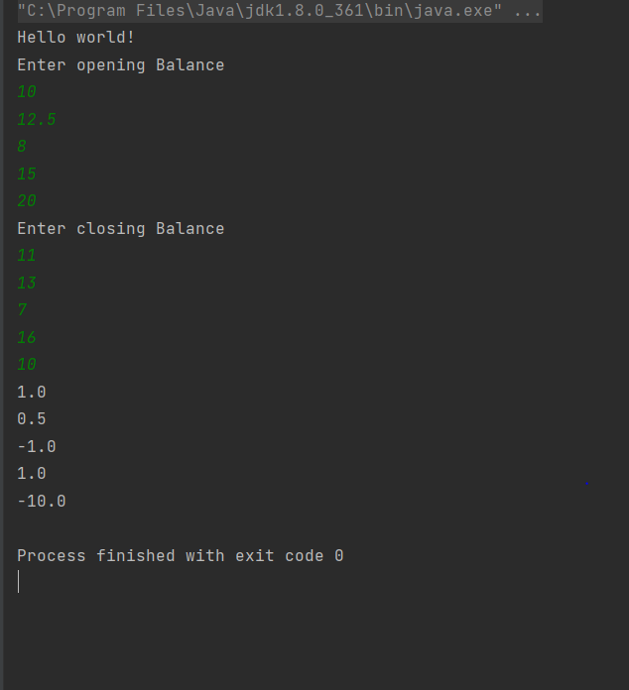

Q2

import java.util.AbstractList;  
import java.util.ArrayList;  
class DuplicateRemover{  
 static void removeDuplicate(ArrayList<Integer> arr){  
 ArrayList<Integer> solved = new ArrayList<Integer>();  
 for ( int i=0;i< arr.size();i++){  
 int number = arr.get(i);  
 if (!solved.contains(number)){  
 solved.add(number);  
 }  
 }  
 for (int j=0;j< solved.size();j++){  
 System.*out*.println(solved.get(j));  
 }  
 }  
 }  
class MAIN{  
 public static void main(String[] args) {  
 ArrayList<Integer> array = new ArrayList<>();  
 array.add(1);  
 array.add(2);  
 array.add(3);  
 array.add(1);  
 array.add(4);  
 array.add(2);  
 array.add(5);  
 DuplicateRemover.*removeDuplicate*(array);  
 }  
}

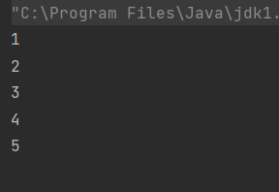

Q3

import java.util.ArrayList;  
import java.util.Scanner;  
  
public class Main {  
 public static void main(String[] args) {  
 int Esum=0,Osum=0;  
 System.*out*.println("Hello world!");  
 Scanner get = new Scanner(System.*in*);  
 ArrayList<Integer> getnumber = new ArrayList<Integer>();  
  
 System.*out*.println("Enter 5 Numbers");  
 for (int i=0;i<5;i++){  
 int add = get.nextInt();  
 getnumber.add(add);  
 }  
 for (int j=0;j< getnumber.size();j++){  
 int number = getnumber.get(j);  
 if (number%2==1){  
 j=getnumber.size();  
 System.*out*.println("Prime");  
 Esum = getnumber.get(0)+getnumber.get(2)+getnumber.get(4);  
 }  
 else {  
 Osum = getnumber.get(1)+getnumber.get(3);  
 }  
 }  
 System.*out*.printf("Even Sum is = ");  
 System.*out*.println(Esum);  
 System.*out*.printf("Odd Sum is = ");  
 System.*out*.println(Osum);  
  
 }  
}

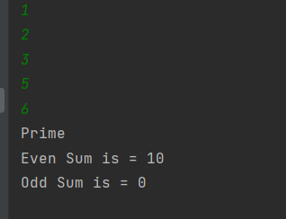

Q4

class student{  
 String name;  
 int rollNo;  
 static String *uniName*;  
 static int *counter*=0;  
 {  
 //static int newroll(){  
 *counter*++;  
 // }  
 }  
 // static int getroll=newroll();  
 public student(String name) {  
 this.name = name;  
 rollNo=*counter*;  
 }  
 public static void change(String uname){  
 *uniName*=uname;  
 }  
 void display(){  
 System.*out*.println(rollNo+" \n"+name+" \n"+*uniName*);  
 }  
}  
class MAIN{  
 public static void main(String[] args) {  
 System.*out*.println("HEllo JAVA");  
 student s1 = new student("Partham");  
 student s2 = new student("Kumar");  
 student s3 = new student("Chawla");  
  
 student.*uniName*="FAST";  
 s1.display();  
 s2.display();  
 s3.display();  
 }  
}

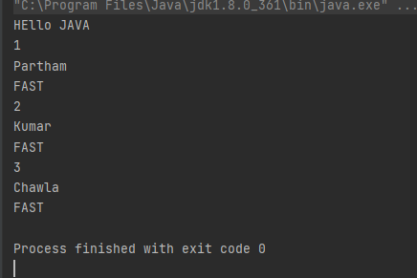

Q5

class car{  
 String make;  
 String model;  
 int year;  
 double pricePerDay;  
 void display(){  
 System.out.println("MAKER "+make+" \nModel "+model+"\nYear "+year+"\nRent per day "+pricePerDay);  
 }  
  
}  
class Rental{  
 static int numRentals = 0;  
 static double totalRevenue = 0;  
 static void rentCar(car c,int days){  
 numRentals++;  
 totalRevenue= c.pricePerDay\*days;  
 }  
}  
public class Main {  
 public static void main(String[] args)  
 {  
 System.out.println("Hello world!");  
 car c1 = new car();  
 c1.make= "Toyota";  
 c1.model="city";  
 c1.year=2019;  
 c1.pricePerDay=10;  
  
 Rental.rentCar(c1,5);  
 c1.display();  
 System.out.println("Total REVENUE IS "+Rental.totalRevenue);  
 }  
}

